INVESTIGATION OF THE GEOSOCIAL OBSTACLES IN THE CURRICULUM DEVELOPMENT OF CIVIL ENGINEERING PROGRAMS IN VIETNAM

Duong T Nguyen, Duc V Tran, Chau M Duong
Faculty of Civil Engineering, Duy Tan University, Vietnam

Thang C Nguyen
Department of Students’ Research, Duy Tan University, Vietnam

ABSTRACT

After three years of the CDIO deployment in the Faculty of Civil Engineering at Duy Tan University (DTU), a number of improvements have been accomplished, namely students’ flexibility and adaptability under various learning or working conditions. Most students are now more proactive and progressive in their learning approach despite of the fact that Civil Engineering is always a dull and demanding discipline. A recent survey, however, showed that while improvements are prevalent, the rates of improvement were not as fast as expected, especially in students’ communication skills and creativity capacity, which are much worse compared to those of students in Western countries. Further analysis has demonstrated a number of geo-social difference reasons for this reality, namely cultural barriers in Asia, the passiveness of Vietnamese students, the non-relevance nature of certain soft-skill and career-planning courses, the gap between what is taught in school and what is carried out in the industry in Vietnam, etc. Understanding these geo-social differences is one of the many efforts in our continuous improvement of the CDIO model for Civil Engineering at DTU. And of course, our findings will offer great insights for universities and colleges in Asia, which are looking for ways to overcome traditional barriers in Civil Engineering education. A series of solutions are also proposed throughout this paper, accordingly.

KEYWORDS
Asian cultural values, CDIO Standard No. 2, 8, 9, 11, Civil Engineering, curriculum development, entrepreneurship, geo-social obstacle, soft skill development

1. INTRODUCTION

Civil Engineering career is always in high demand, and it requires a great deal of technical and professional training. In developing countries like Vietnam, most current training programs in Civil Engineering still focus on the theoretical knowledge due to the traditional training methods and the lack of training laboratories. A CDIO approach is recommended to help students develop both of their “hard skills” and “soft skills” in a comprehensively manner so as to quickly adapt to any working environment.

Since 2001, many universities around the world have applied the CDIO model for their engineering programs. For Civil Engineering, Vigild M. had reported the inspiration in creating novel Design-Build projects for the B ENG programs of Denmark Technology University in Civil Engineering, Architecture, IT, Electrical Engineering, Chemical Engineering and Mechanical Engineering (Vigild et al, 2009). A design-directed curriculum based on CDIO principles was also proposed for the program of Civil Engineering at Shantou University in China (Xiong & Lu, 2007). It is indicated that the designed-directed CDIO curriculum put students in a broad and active design environment where they learn and apply sciences, technology, engineering knowledge and non-engineering knowledge as well as to exercise their project management, communication and leadership skills. Another article by Anette Krogsbøll described four projects in the Civil Engineering study program also at Denmark Technology University along with a brief description of the entire study program (Krogsbøll, 2011). Learning outcomes, training methodologies, assessment of personal, professional and social engineering skills were described from a project point of view while progress in engineering skills was discussed from a study-program perspective. Since the CDIO model are designed and implemented according to a standard process, it needs a systematic solution for the re-investment and redistribution of resources within an organization so as to reduce any cost related to a new training scheme - this is especially relevant to a rather costly training discipline like that of Civil Engineering.

Almost every engineering study program nowadays include a mix of theoretical and practical or laboratory-based courses. The big question becomes how to adapt them with the CDIO framework and implementation guidelines with the least number of modifications. A case study for Civil Engineering programs at DuyTan University is being investigated to answer this question: Some add-on modules have been added into the current curriculum to help students develop necessary skills for the CDIO projects besides a series of “soft-skills” and career-planning courses. Several smaller projects or practical group games are also integrated into already-available courses. CDIO project courses in Civil Engineering at Duy Tan University would focus on comprehensive technical solutions for buildings and structures to cope with the natural disasters in Vietnam including floods, hurricanes, landslides and earthquake. It is also important that these solutions are at a minimal cost to fit with the economic conditions in Vietnam and at the same time, meeting the requirements of the CDIO framework.

Over the last three years of CDIO deployment, a number of improvements have been accomplished by the Faculty of Civil Engineering of Duy Tan University, namely in students’ creativity, flexibility and adaptability for various learning and working conditions. A survey was carried out to measure students’ perception about the success and failure of our CDIO deployment. Study results and feedbacks were relatively encouraging with most students now become more proactive and progressive in their learning skills and approach. Basically, the survey was based on the description of various disciplinary fundamentals in Part 1 of the CDIO Syllabus, which are necessary for any particular engineering education, as stated in the CDIO Syllabus (Crawley, 2001). As depicted in Figure 1 below, the building blocks of skills, knowledge and attitudes serve as a reminder that the development of working knowledge in technical fundamentals is and should always be the primary objective of any undergraduate engineering education.

CDIO
1. Technical Knowledge  and Reasoning | 2. Personal and  Professional Skills | 3. Interpersonal  Skills
Figure 1. Building blocks of knowledge, skills, and attitudes necessary to
Conceive, Design, Implement, and Operate (CDIO) Systems in the Enterprise and Societal
Context (Crawley, 2001).

The remainder of the CDIO Syllabus is arguably common to all engineering professions: That is, engineers in any field use approximately the same set of personal and interpersonal skills, and follow approximately the same generalized processes. Therefore, our survey questionnaire took after the sample survey in the report of Edward Crawley in 2001 with some modifications that focus on Part 2 and 3 of the CDIO Syllabus (Crawley, 2001).

2. CDIO APPROACHIN CIVIL ENGINEERING PROGRAMS AT DUY TAN UNIVERSITY

2.1. Objectives:

The modifications made to our Civil Engineering curriculum over the last three years since our CDIO adoption are to adapt to the regularly changing details of the CDIO framework, hence, we only make the least number of modifications each time, which are essential and necessary to a standard CDIO curriculum:
- Add-on modules were created to help Civil Engineering students develop needed skills for carrying out modular and comprehensive CDIO projects.
- The focus of our Civil Engineering CDIO projects are usually on dealing with natural disasters and catastrophes in Vietnam.
- The modifications accommodate for the economic conditions of a typical institution in Vietnam, which has insufficient education budget and lacks of various hi-tech training equipment and laboratories.
- Add-on courses to help students improve their soft skills and career-planning tactics.

2.2. Basic CDIO Projects:

At the basic level during the sophomore and junior years, CDIO projects help teach students about certain aspects of Mechanical Science which is the most fundamental knowledge of many Civil Engineering domains. More than often, Mechanical Science is very difficult for students to understand and apply because it integrates both applied Physics and Mathematics. The goal of the CDIO projects here is to guide students through the application of mechanical theories to solve some real-world problem like retaining walls or constructing truss bridges or maximizing load. Students may not understand all aspects of the theories at first, but through the fruitful applications, they will come to understand the theories to a certain degree.

Given the 4 different stages of the CDIO model, including Conceive, Design, Implement and Operate, a typical retaining wall project would be like this:

- Conceive stage: Students will do research on landslides and its consequences. Then, they would search for existing solutions for retaining walls in case of landslide. They would try to understand the theoretical and technical aspects of those already-available solutions to certain extent. Based on that newly-found knowledge, students would propose some “new” and general designs for retaining walls under the requirements that they would save the most amount of materials and at the same time, optimizing the strength of the proposed structures.

- Design stage: The instructor will provide students with information on various parameters of the terrain and the landslide, and students would need to propose their design structures for the retaining wall. It is important that students would integrate knowledge from various courses learned before:
  - Surveying course: measuring, modeling and drawing skills
  - Hydraulics course: the ability to determine the permeability coefficient and the force of flows on the ground
  - Geotechnical Engineering course: practices in surveying various geotechnical properties and conditions
  - Soil Mechanics course: the ability to assess the physical and mechanical properties of soil, and to apply knowledge about soil mechanics into calculating the strength of the proposed wall
  - Statics course: the ability to design for the balance of the structures and the stability of the retaining wall
  - Strength of Materials course: the ability to compute the bearing capacity of the proposed retaining wall
  - Civil Engineering Software course: the ability to run the proposed structures on software such as Plaxis or Sap so as to provide analysis and evaluation of the corresponding virtual model

- Implement stage: In Civil Engineering, the design on paper versus the actual construction always yield many differences. At the construction phase, there may be some inconceivable challenges of reality. As a result, during this stage, students are asked to build a small model of their proposed design of the retaining wall from the previous stage.

In order to successfully build these models, students would need to know all the necessary calculations in mechanics plus typical designs under certain circumstances. The instructor may adjust certain parameters for each group to test their skills and knowledge, for example, making the landslide slope flatter or adjusting the moisture level of the soil, etc. Students would fix their design accordingly, and use devices like stress or strain tensor to test and verify the mechanics of their model. Essentially, students would have to go back and forth between this stage and the Design stage to eventually arrive at an actual model built by themselves. The outcome we look forward to is the knowledge that our students would learn in the process.

- Operate stage: By theory, a construction is good if it can go through a series of operation trials under different conditions and ultimately, the test of time. The fact, however, is that once the construction is done it is very difficult to go back and fix design or implementation problems. The same situation applies here, and the instructor would mostly test the qualities of the built models. With the CDIO project of retaining wall, the instructor will evaluate students based on the calculations made for their built model in terms of soil mechanics, hydraulics and statics. In addition, the ratio of the wall weight to the maximum weight that the retaining wall may withstand will be computed to evaluate students on their design and use of materials.

Another basic project usually held during the junior year is the “O Thuoc Bridge Building” project which helps integrate and apply knowledge from the courses of Strength of Materials and Structural Analysis. Specifically, students are asked to design and build a bridge model from wood or bamboo chopsticks with a specified span length and solid structures that can sustain certain amounts of weight and load. The instructor will grade teams based on their ideas for some new structures of the bridge as well as their choice of materials when building the bridge in reality. The ultimate evaluation criterion, however, is the ratio between the weight of the bridge and the weight that the bridge can withstand. A small competition show can be set up, in which the bridge models of students will do “weight-lifting” against each other until the last one stands as the winner.

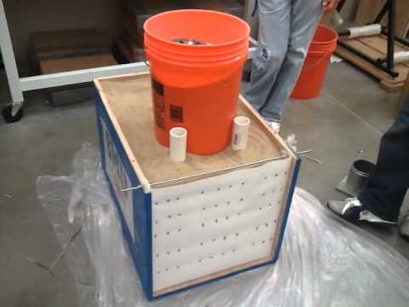
Figure 2. Building the model of Retaining Wall from carton paper at DTU

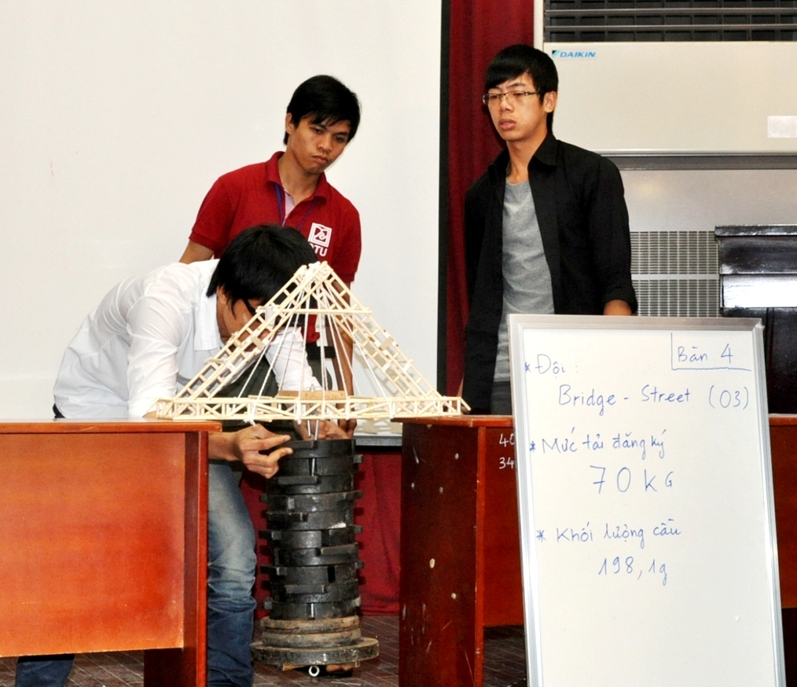
Figure 3. Testing the loading capacity of a bridge model inthe "O-Thuoc bridge" Project

2.3. Advanced CDIO Projects:

The topic for the senior year CDIO project is the design of some earthquake-resistant building. Students are asked to make a model of their earthquake-resistant building from wooden bars. They would need to apply knowledge from courses of Structural Analysis, Strength of Materials, Structural Dynamics, Skyscrapers, etc. Depending on the year, the actual material of the wooden bars will be chosen by the Faculty of Civil Engineering. The choice of material will have a direct effect on students’ designs, and only teams who understand the implications may score high in this project.

Criteria for evaluation is taken directly from those of the Asia-Pacific Earthquake-Resistant Model Building Tournament organized every year in Taiwan. The best team in Duy Tan University is usually chosen to participate this annual tournament in Taiwan. In 2014, the team from DTU had won the championship of this tournament.

2.4. Soft-Skills and Career-Planning Courses:

Our goal in training Civil Engineering students is that besides strong technical and engineering skills and knowledge, students should also “grow” in terms of personal and interpersonal skills and should be able to present themselves at the most professional manner possible in the labour market and working environment. As a result, a number of courses were added to the traditional Civil Engineering curriculum for that purpose:

- Professional Speaking course: This course provides students with basic skills in public speaking including speech preparation, speech delivery, audience analysis, and the oral communication process and theory. Additional presentation and visual-aids techniques are also introduced.

- Professional Writing course: This course introduces students to various writing styles both for academic and corporate purposes. Academic writings consist of different types of essays like Persuasion, Compare/Contrast, Argumentation, etc. while business writing assignments include memos, reports, job descriptions, letters, emails, proposals, white papers and blogs.

- Critical Thinking course: This course is all about methods for collecting data, processing information, and making informed decisions from small issues of everyday life to major challenges of a life-changing nature. Students are also introduced to scientific writing methodologies like APA or MLA, or ways to effectively use library resources for their study, or problem-solving methods in typical case studies of the Harvard Business Review.

- Career-Planning 1 and 2 courses: The first and second courses in Career Planning at Duy Tan University provide an overview about the learning environment and academic cultures of Duy Tan University. Besides academic regulations and formal procedures of various academic affairs, students will get to learn about personal development, time management, financial management, career orientation, etc. to better prepare for their four or five years in college.

- Career-Planning 3 course: Students will learn about the core values and activities of their future career in Civil Engineering. List of all job titles and job descriptions in Civil Engineering will be provided besides bi-weekly visits or field trips to actual construction companies and enterprises.

Except for the Career-Planning 3 course, which is prepared by the Faculty of Civil Engineering, the rest of these “soft-skills” and career-planning courses are managed directly by the Board of Vice Provosts, who are in charge of General Education for the whole school. In a way, this is very fruitful because the school can set the direction for soft-skills training university-wide based on their overall studies of students’ characteristics in any one intake; but at the same time, this may be counter-productive because the materials being taught are too general and not discipline-specific.

3. SURVEY, RESULTS, AND DISCUSSIONS

It can be said that while personal and interpersonal skills are of a general nature, they are closely-tied with professional skills, which include professional behaviour at work and professional integrity codes by the industry. Professional skills, on the other hand, are tied up with technical skills and knowledge of a specific discipline or industry. This interrelated relationship may be best described schematically in the Venn diagram in Figure 4 below:

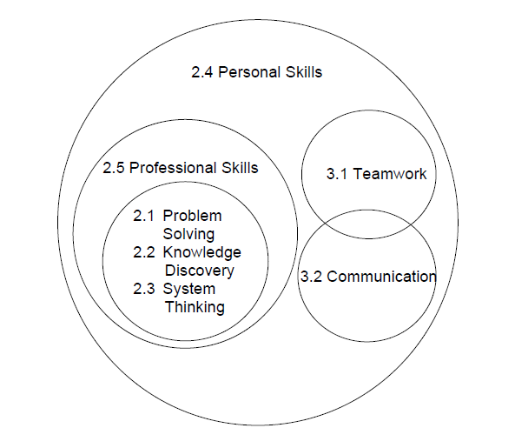
Figure 4. Venn diagram of Professional, Personal and Interpersonal Skills (Crawley, 2001)

So, in order to assess and evaluate how well our CDIO adoption and continuous improvements in Civil Engineering programs at DTU have been going on so far, we carried out a survey to study the above mentioned interrelationship based on the Venn diagram. A sample of 124 Civil Engineering students from freshmen to seniors were chosen for this study. The 7 aspects of the Venn diagram were grouped into 4 major categories of the UNESCO Framework to the Context of Engineering Education, and a Likert rating scale of 1 to 5 was adopted. As a result of the adaptation of the UNESCO framework for engineering education, the CDIO Syllabus were divided into four major categories:

- Technical Knowledge and Reasoning or UNESCO Learning to Know: equivalent to items 2.1, 2.2 and 2.3 in the Venn diagram.

- Personal and Professional Skills and Attributes or UNESCO Learning to Be: equivalient to items 2.4 and 2.5 in the Venn diagram.

- Teamwork, Communication and Interpersonal Skills or UNESCO Learning to Live Together: equivalent to items 3.1 and 3.2 in the Venn diagram.

- Conceiving, Designing, Implementing and Operating Systems in the Enterprise, Societal and Environmental Context or UNESCO Learning to Do: equivalent to all the technical and engineering skills and knowledge that students learn from our Civil Engineering curriculum.

The survey was carried out three months ago, and the survey results are generally depicted in Figure 5 below, corresponding to the 7 major aspects of the Venn diagram:
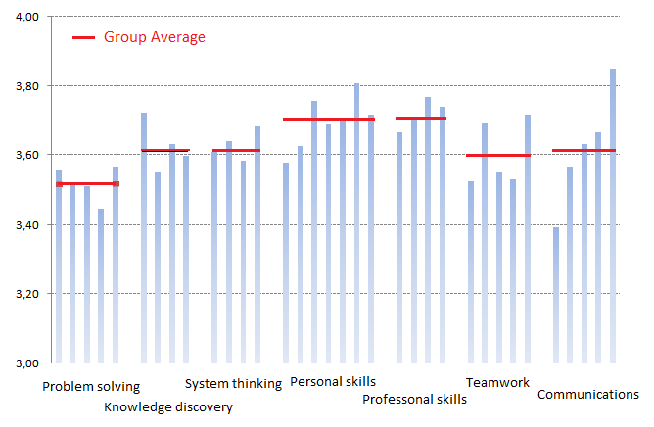
Figure 5. Survey Results about Perceived Students’ Skills in Civil Engineering at Duy Tan University, following major aspects of the Venn diagram

The survey results show our success in improving students’ personal and professional skills with the highest average ratings and little variance between different results. This is a strong evidence for our success in restructuring the CDIO projects and related technical coursework. Courses like Career-Planning 2 & 3, Professional Writing and some topics in the Critical Thinking course contributed partially to this success. This may also have to do with the good qualities of Asian and Vietnamese students in that they are very hard working, have strong knowledge of natural sciences, and possess the ambition for future career development. Another aspect that showed sign of improvement is teamwork, however, its improvement level was not as significant as expected.

In contrast, survey results still showed weakness in our students’ communication skills and creativity capacity. This signified the failure of many topics being taught in the courses of Professional Speaking, Professional Writing and Critical Thinking. Since these very same courses are very effective for students in business and other engineering disciplines, it can be said that they were not a good match for Civil Engineering students. There may be a number of reasons for this reality that can be further elaborated on:
- The rate of improvement in communication skills of our Civil Engineering students ever since the adoption of CDIO was not as fast as expected, especially, when compared with those of students in Western countries from previous case studies (Crawley et al, 2007). A number of geo-social reasons are responsible for this: Cultural barriers continue to be a major obstacle for open discussion and independent demonstration of new ideas by Vietnamese students. In addition, anothermajorshortcoming of Asian as well as Vietnamese students is their passiveness and warriness of new approach or ideas (Runckel, 2011). This usually leads to passive learning which is the opposite of what CDIO is asking for: Active Learning and Teamwork.

- A major source of negative effect on our students’ creativity has to do with their high-school education. Indeed, most Asian and Vietnamese high-school students rarely have the chance to express their ideas about the learning subjects - they simply accept and memorize whatever their teachers have to say. High school also lack courses which help develop students’ independent mindset and interpersonal skills. To compensate for this shortcoming, we have provided a number of “soft skills” courses like mentioned, however, these courses were not designed specifically for students in the field of Civil Engineering. Therefore, the new soft skills developed generally do not appear to be as beneficial as expected.

- Another shortcoming in our current Civil Engineering curriculum is that due to the focus on career-planning practices, entrepreneurship skills are mostly ignored. This is actually a major weakness of Vietnamese and Asian students when compared to Western students, and more than often, this hinders our students from thinking big or becoming creative.

- New technologies in Civil Engineering are now rapidly introduced in schools, but not all of them have been adopted by businesses in the construction industry in Vietnam. This creates a certain gap for our students in their approach when they come to work for real-world companies and enterprises because they cannot be as active and flexible as they may want to be.

4. PROPOSED SOLUTIONS FOR CONTINUOUS IMPROVEMENT OF THE QUALITY OF CDIO DEPLOYMENT IN CIVIL ENGINEERING AT DUY TAN UNIVERSITY

Many factors shape the quality of learning. These include:
- The aptitude and motivation of individual students, and their corresponding approach to learning, including their habits for teamwork and collaborative learning,
- The quality and diversity of the student body at the Faculty of Civil Engineering, which students are part of,
- The curriculum of Civil Engineering at DTU,
- The caliber and methodologies of the teaching faculties,
- The size and nature of specific Civil Engineering classes,
- The assessment and evaluation standards and/or processes,
- The learning resources (such as libraries, laboratories),
- etc.

Given the conditions in Vietnam, there are definitely many limitations at almost all of the above factors. How to effectively approach such limitations becomes the ultimate solution in improving the quality of our CDIO deployment for Civil Engineering. Below are three of the most forthcoming solutions proposed:

First of all, we have to pay attention to the teaching methodologies and practices. There is a unanimous need amongst our faculty members that we should seriously refine our teaching methodologies so as to attain specific learning outcomes. This is very much relevant to the fact that CDIO is an outcome-oriented model. In particular, we would need to engage students in Active Learning through in-class participation, discussion and debates, group games, etc. Students should also be encouraged to voice out their ideas and to be independent in their thinking and problem-solving. And yet, we need to educate our students of the advantages and disadvantages of the Vietnamese cultures to their learning habits, and how those may affect their future career in the field of Civil Engineering. This would raise students’ awareness of certain pitfalls that they may run into in their current study as well as future career.

Secondly, the roles of our Civil Engineering instructors need to be restructured. It is a common knowledge that three major roles of an instructor is: Teaching, Doing Research and Providing a Service, still, it seems our instructors currently only do the teaching or worse, lecturing to be exact. As a result, the only add-on course of Critical Thinking may not help much in developing students’ research capacity. Unless the instructors proactively engage students in research activities, most of the time, students will drop out halfway through some research project. Strict and formal research methodologies should not be the focus at this point because they may make students lose heart, instead, fostering the spirit of lifelong study and creativity through small research projects are two of the major things that need to be done here. As for the role of providing a service, this is actually not very much welcome in East Asian cultures. While maintaining certain distance between the instructors and their students helps create a strong level of respect, it may actually lead many of the instructors in Vietnam, no matter what discipline they are in, to believe that they are doing a favour to the students, or students come to class to learn directly from them, and not from any other sources. This mentality definitely will hinder creativity, and was the reason why so many instructors in Asia quickly announced that they had exercised everything of the CDIO model, but with no success.

Thirdly, the Faculty of Civil Engineering and its instructors need to create a healthy academic atmosphere and environment for students to grow their maturity in various aspects. At the most basic level, instructors should not always require fast answers from students on their projects or assignments. Instead, students should be given the time and step-by-step guidelines to go through the process on their own. In other words, the ultimate relationship of instructors to students is that of a guide, not of a dictator. Students should feel comfortable asking questions or arguing for their points to freely participate in any academic or professional discussion. They also need to learn that mistakes are common for progress, and even the instructors can make mistakes at any point. At a higher organizational level, the Faculty of Civil Engineering should provide students with adequate lab facilities and other learning equipment. Restructuring and renovating of individual and team learning spaces across the campus is also important in any CDIO deployment.

Last but not least, in sending students to real-world construction companies and enterprises, the instructors should have a clear agenda about what and how students may learn. Many times, these visits in the Career-Planning 3 course is an exchange of formality, and students were left out in the process. In addition, CDIO projects which are carried out with outside companies or businesses need to have a clear financial budget and plan to avoid interruptions at a later stage in the project when funding may be running out.

5. CONCLUSION

Ever since our deployment of the CDIO model for Civil Engineering programs at Duy Tan University three years ago, we have continuously run into problems and issues that need to be addressed and fixed. While various problems of technical coursework in Civil Engineering and related disciplines have been settled down to certain extent, the problem of developing students’ communication skills and creativity continues to be a major challenge. Much of the reason has to do with cultural barriers in Asia as well as the passiveness of students in Vietnam due to their high school background and education. Bit by bit, we have sorted out certain problems to enhance individual students’ personal, teamwork and communication skills, but there is still no general solution approach to this problem. Future studies should focus more on the Conceive stage in the CDIO projects for our Civil Engineering so as to enhance their creativity and independent study. In addition, the use academic clubs in Civil Engineering should be studied to determine if additional extra-curricular activities in Civil Engineering may help with faster maturity of our students both in their professional knowledge and communication skills.

REFERENCES

Crawley, Edward F. (2001). The CDIO Syllabus. A Statement of Goals for Undergraduate Engineering Education.

Crawley, Edward F., Malmqvist, Johan., Östlund, Sören, Brodeur, Doris R. (2007). Rethinking Engineering Education: The CDIO Approach. U.S.: 2007.

Krogsbøll, A.,Simonsen,C., Christensen, J. E., Larsen, T. B., Goltermann, P., Koss, H. and Sand, J. (2011).CDIO Projects in Civil Engineering Study Program at DTU. Proceedings of the 7th International CDIO Conference, pp. 107-115.

Ministry of Planning and Investment, General Statistics Office (2009).Education in Vietnam: An Analysis of Key Indicators. Vietnam Population and Housing Census 2009.

Runckel, Christopher (2011). The Education System in Vietnam. Runckel & Associates: http://www.Business-in-Asia.com

Vigild, Martin E., Willumsen, Louise E., Borchersen, E., Clement K., Jensen, Lotte B., KjærgaardC., Klit P. and Sparsø J.(2009). Comparison and Classification of Design-Build Projects in Different Engineering Bachelor Programs. Proceedings of the 5th International CDIO Conference, pp. 59-68.

Xiong, Guangjing & Lu, Xiaohua (2007). A CDIO Curriculum Development in a Civil Engineering Programme. World Transactions on Engineering and Technology Education, Vol.6, No.2, pp. 145-153.

BIOGRAPHICAL INFORMATION

NGUYEN,Thang Chien, Ph. D. is a researcher in the Civil Engineering Research Group of the Institute of Research & Development, Duy Tan University. His research interests include green buildings and green construction materials. His current academic activities focus on the implementation of CDIO for the Civil Engineering programs at Duy Tan University.

NGUYEN, Duong The, Ph. D. is the Dean of the Faculty of Civil Engineering. His research interest is in Structural Design and anti-fire materials.

TRAN, Van Duc, M.Eng. is a faculty member of the International School, Duy Tan University. His research areas include vehicle-bridge interaction and steel-bridge materials.

DUONG, Chau Minh, M.Eng. is a faculty member of the Faculty of Civil Engineering. His research interest is in concrete construction and concrete materials.

Corresponding author

Dr. Chien Thang NGUYEN  Civil Engineering Faculty, DuyTan University,  K7/25 QuangTrung, Da Nang city, Vietnam  84-935-215-664  thang.nguyen@duytan.edu.vn | This work is licensed under a Creative Commons Attribution-NonCommercial-NoDerivs 3.0 Unported License.

